Lecture 2 Tasks

Task 1: Wire up a twisted pair cable from each side.

قمت بتوصيل طرفي الكابل بالوصلة البالستيكية

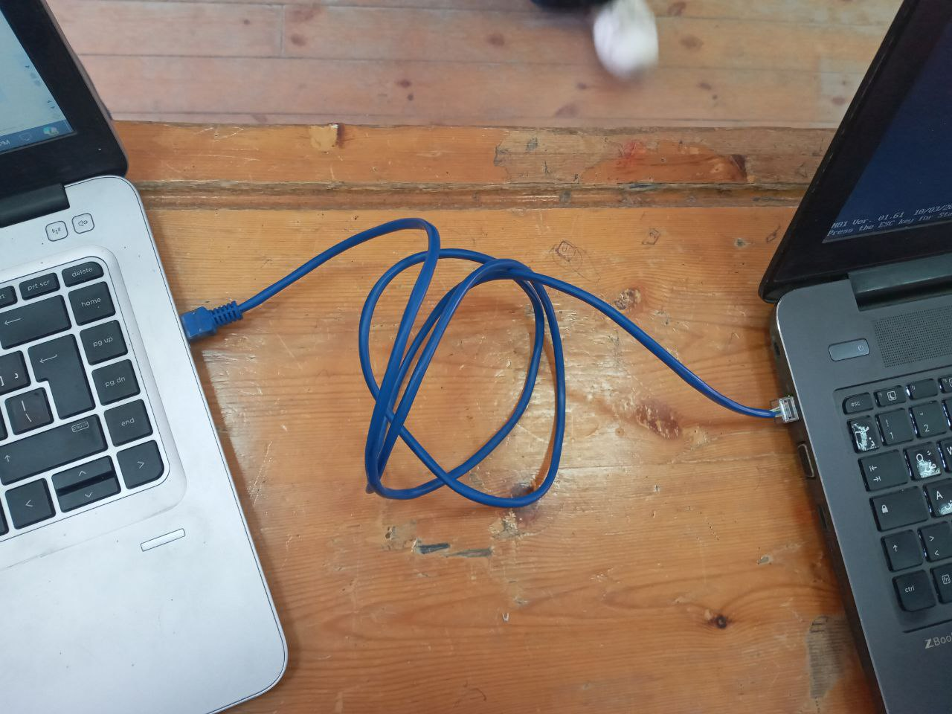

Task 2: Send an image from your laptop to your mobile through Bluetooth.

قم بإرسال صورة من جهاز الالب توب الخاص بك إلى جهاز الموبايل

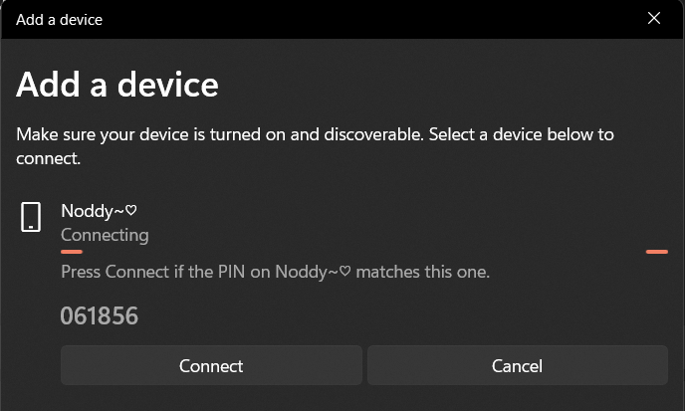

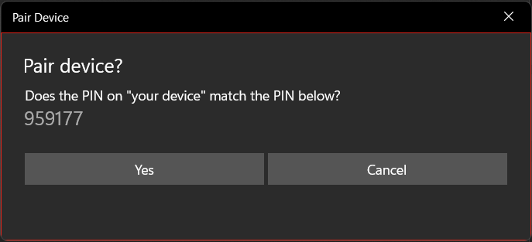

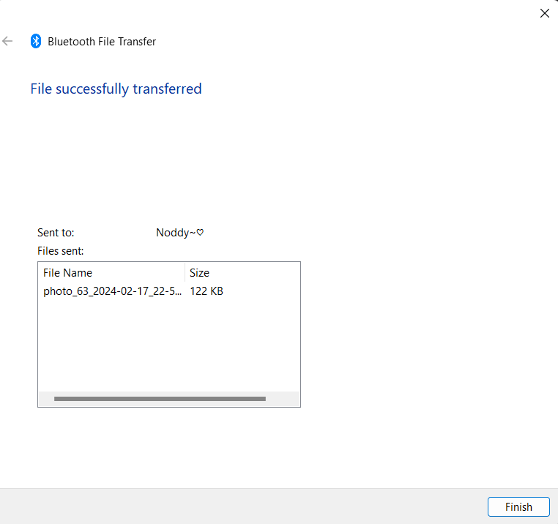

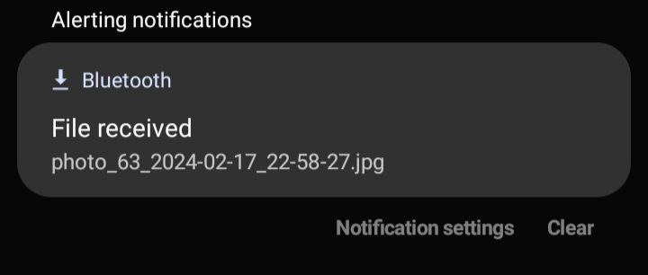

Task 3: Adjust your IP address of your device to be 192.168.1.55 and use another device and make its IP address as 192.168.1.66

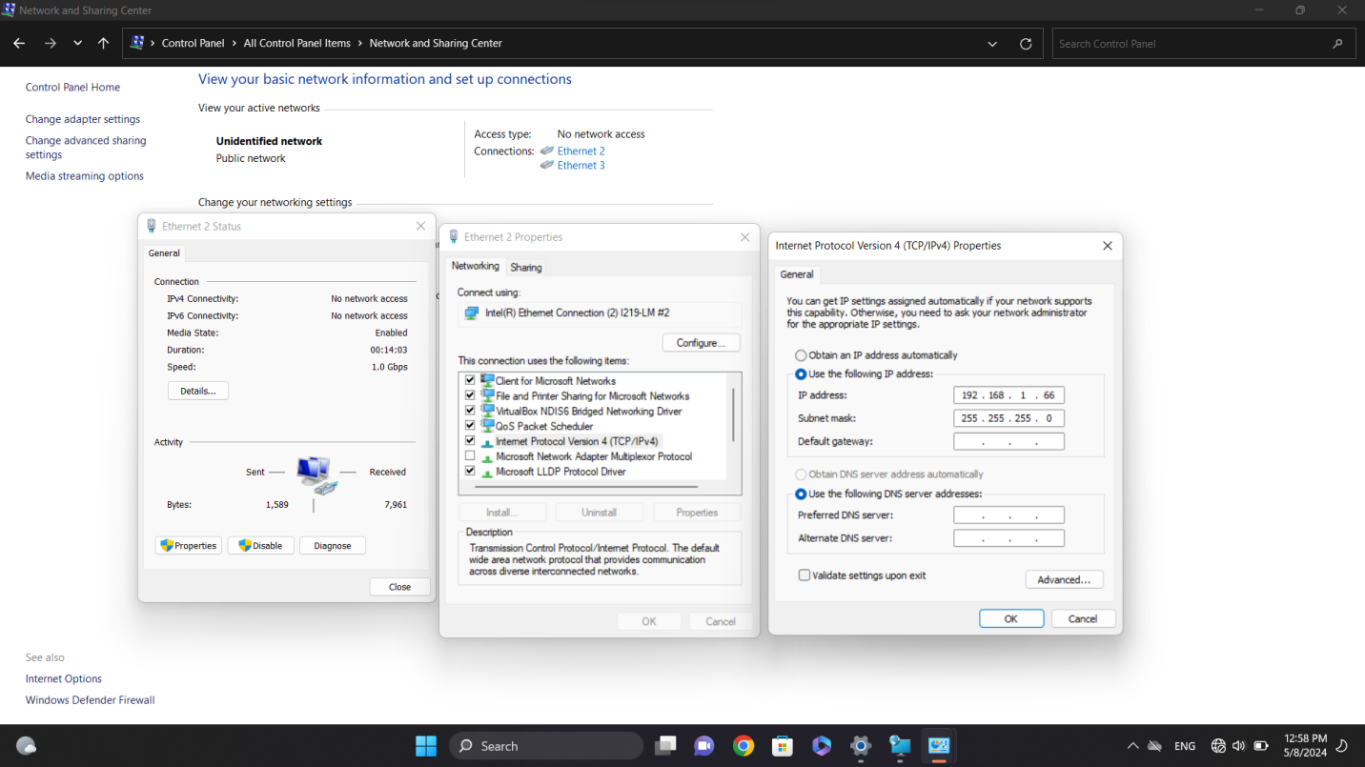

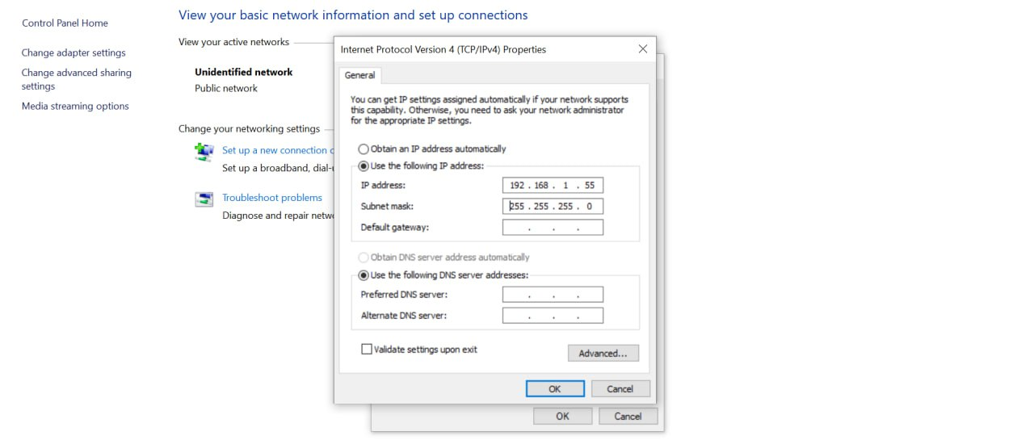

Task 4: Check the reachability of each device from another one by cmd commands.

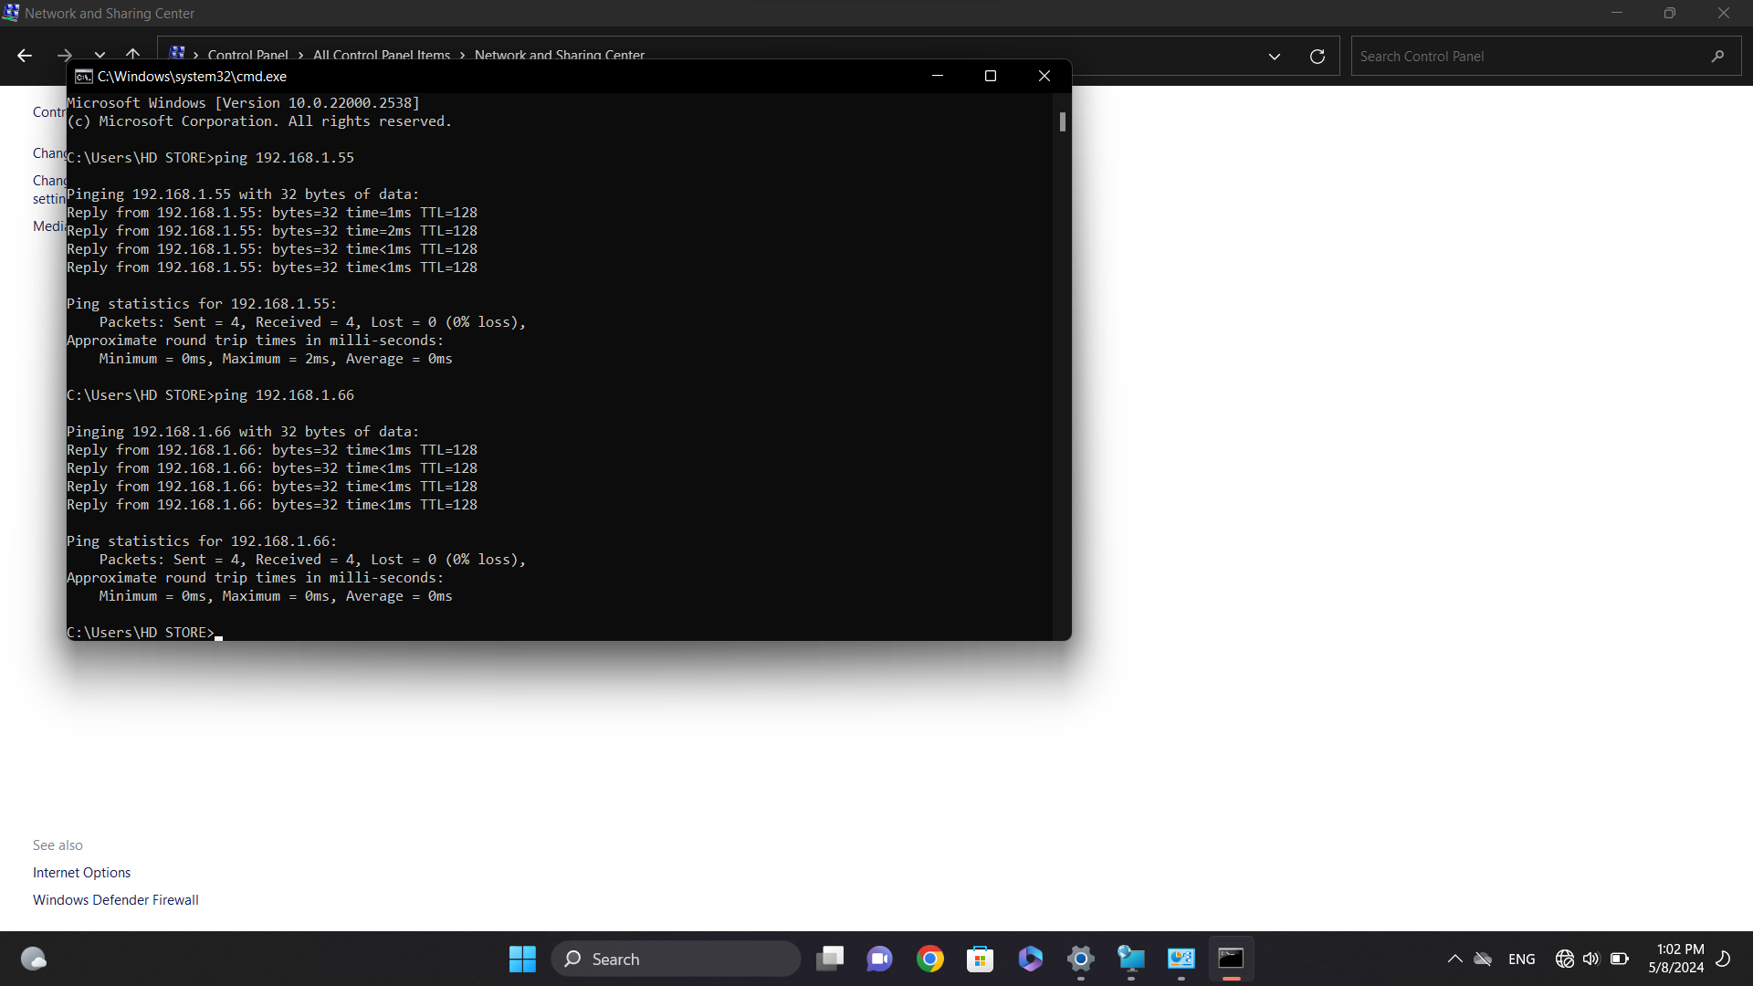

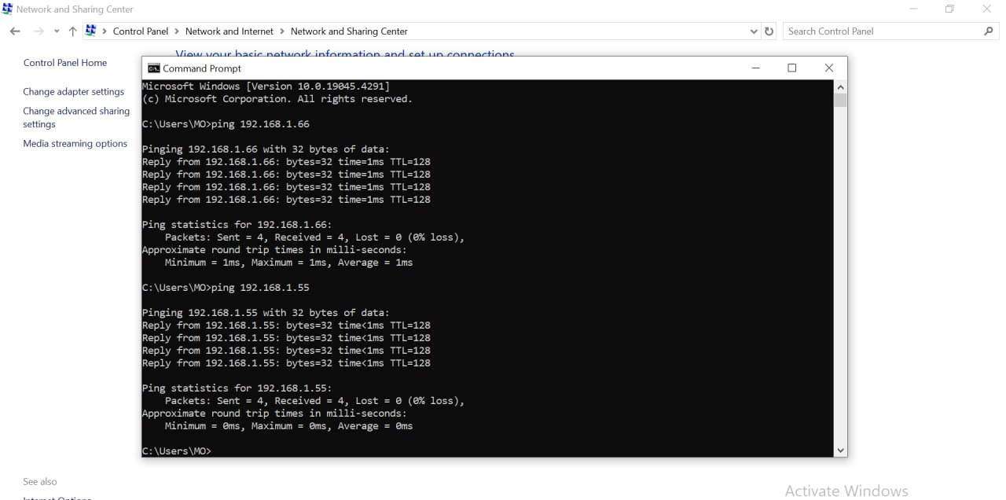

Task 5: In your device, share 3 folders containing some files in 3 different locations to be accessible to every device in the network.

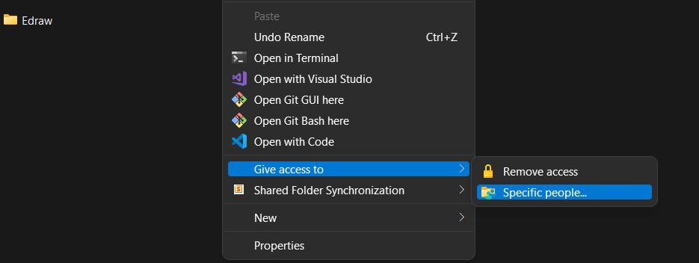

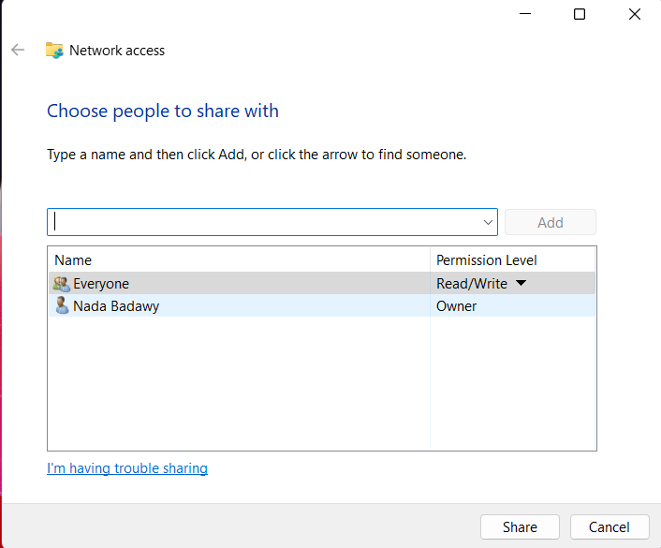

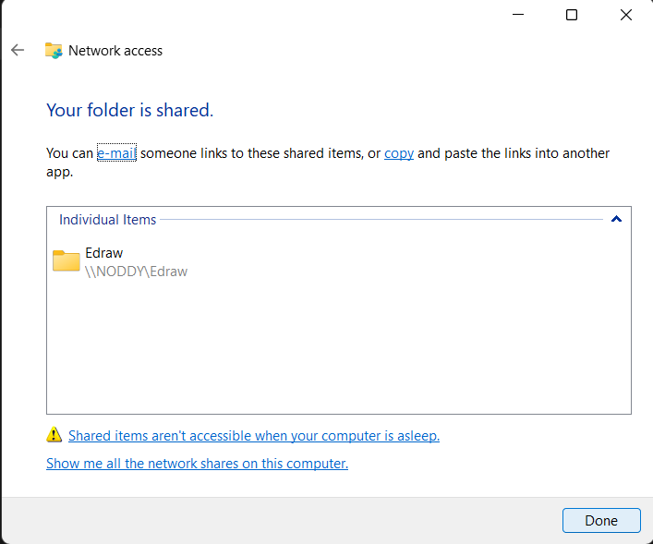

ظهر عندها بالشكل دا

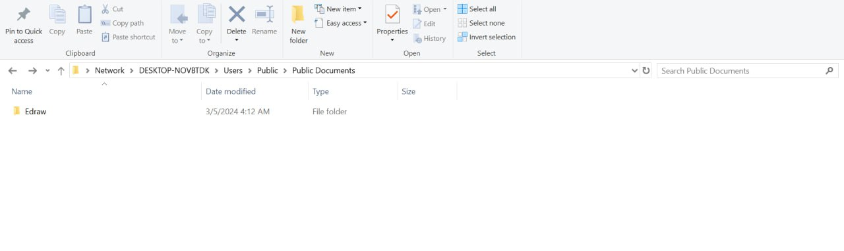

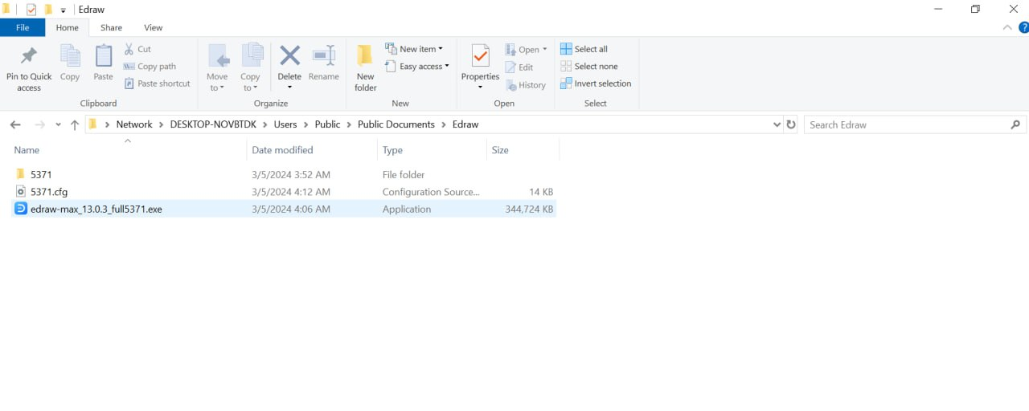

Task 6: Put file in each folder from another device which connected with your device through network.

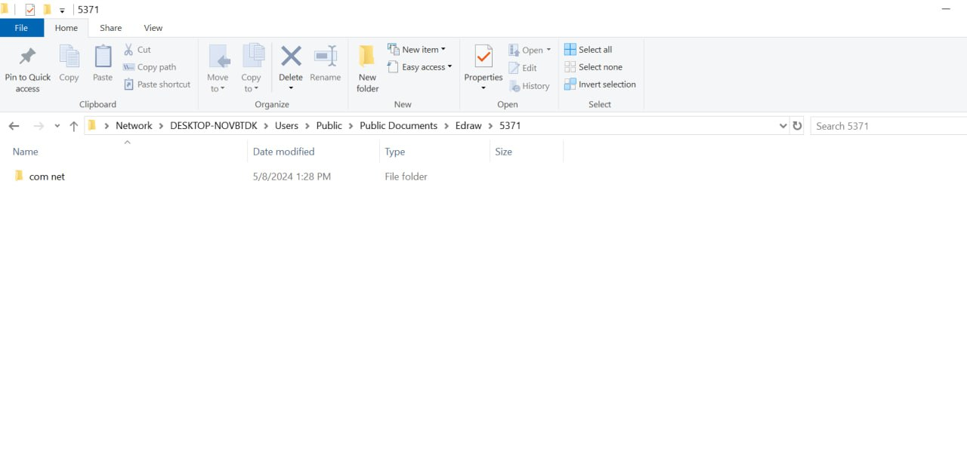ظهر عندي بالشكل دا

